**Code 1:**

#include<iostream>

using namespace std;

int main(){

int i,y,sum=0;

for(i=1;i<11;i++){

cin>>y;

sum+=y;

}

cout<<"sum of ten numbers is "<<sum<<endl;

}

**Code2 :**

#include<iostream>

using namespace std;

int main(){

int number;

cout<<"enter number for table"<<endl;

cin>>number;

cout<<"table of"<<number<<"is"<<endl;

for(i=1;i<11;i++){

cout<<number<<"*"<<i<<"="<<number*i<<endl;

} }

**Code 3:**

#include<iostream>

using namespace std;

int main(){

int x;

int factorial;

cout<<"enter number for factorial"<<endl;

cin>>x;

factorial = x;

for(i=x-1; i>0; i--){

factorial*=i;

}

cout<<"factorial is "<<factorial<<endl;

}

Console of task 1

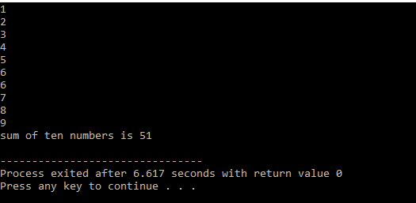

Console task 2

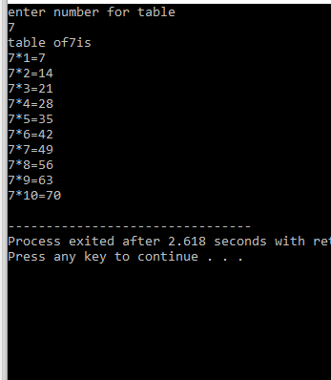

Console task 3

